Project Design Phase-II
Technology Stack (Architecture & Stack)

Date | 10 September 2026
Team ID | SWUID2026190374
Project Name | ServiceNow-Based Employee Laptop Request Application
Maximum Marks | 4 Marks

Technical Architecture:
The Deliverable shall include the architectural diagram as below and the information as per the table1 & table 2
ServiceNow Employee Laptop Request – Technical Architecture
Reference: ServiceNow platform architecture, Service Catalog and Flow Designer
Guidelines:
Include all the processes (As an application logic / Technology Block)
Provide infrastructural demarcation (Local / Cloud)
Indicate external interfaces (third party API’s etc.)
Indicate Data Storage components / services
Indicate interface to machine learning models (if applicable)
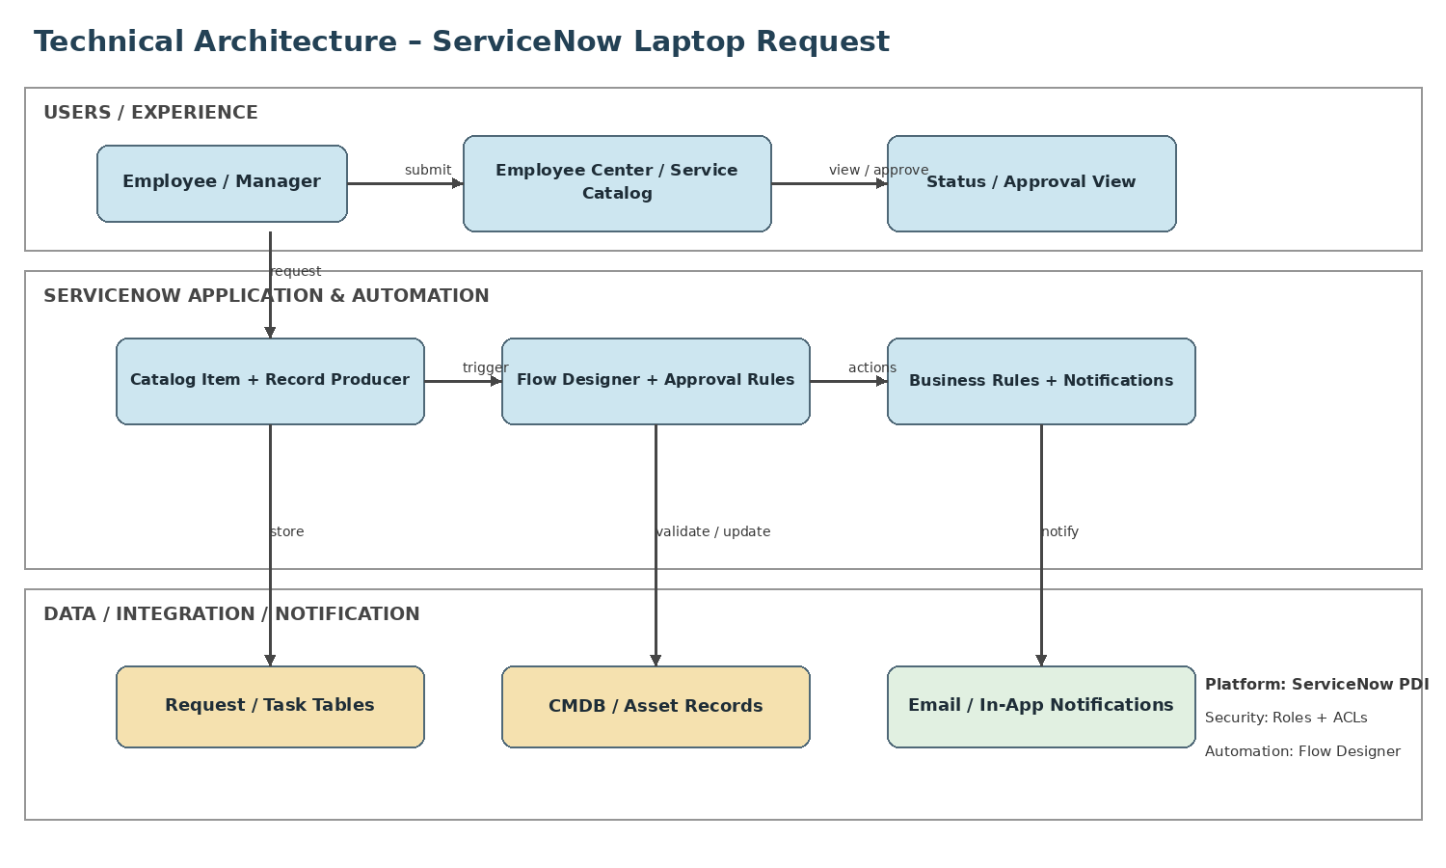

Table-1 : Components & Technologies:
S.No | Component | Description | Technology
1 | User Interface | Employee request and manager approval experience | ServiceNow Employee Center / Service Catalog
2 | Application Logic-1 | Create and validate request | Catalog Item / Record Producer
3 | Application Logic-2 | Route approval and create tasks | Flow Designer
4 | Application Logic-3 | State logic, validation and notifications | Business Rules / Notifications
5 | Database | Requests, tasks, users and workflow data | ServiceNow platform tables / GlideRecord
6 | Cloud Database | Managed platform data storage | ServiceNow Cloud Platform
7 | File Storage | Request attachments when required | ServiceNow Attachments
8 | External API-1 | Optional HR or identity integration | REST APIs / IntegrationHub
9 | External API-2 | Optional asset/inventory integration | CMDB / REST
10 | Machine Learning Model | Not required for core workflow | N/A
11 | Infrastructure (Server / Cloud) | Hosted application instance | ServiceNow PDI / Cloud Platform

Table-2: Application Characteristics:
S.No | Characteristics | Description | Technology
1 | Open-Source Frameworks | No external framework required for the core PDI application. | ServiceNow platform
2 | Security Implementations | Role-based access, ACLs and authenticated sessions. | ServiceNow Roles / ACLs
3 | Scalable Architecture | Catalog, workflow, data and integrations are modular and extensible. | Catalog + Flow Designer
4 | Availability | Uses the managed ServiceNow cloud platform. | ServiceNow Cloud
5 | Performance | Efficient queries, server-side automation and asynchronous notifications. | Glide APIs / Flow Designer

References:
https://c4model.com/
https://developer.ibm.com/patterns/online-order-processing-system-during-pandemic/
https://www.ibm.com/cloud/architecture
https://aws.amazon.com/architecture
https://medium.com/the-internal-startup/how-to-draw-useful-technical-architecture-diagrams-2d20c9fda90d

